**AutoTPA Phase 1 Requirements**

**Administrator Registration**

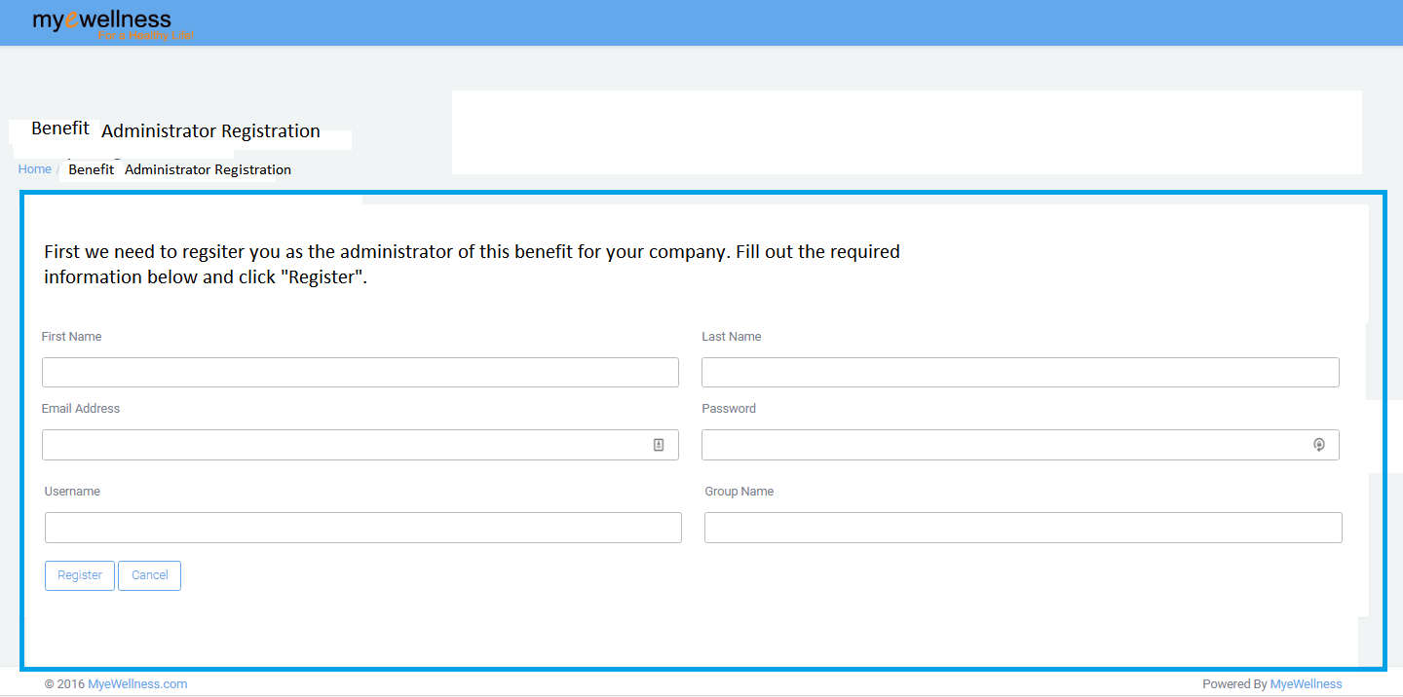

* See updated page info above. Needs better outline/border. ( **design i have no idea)**
* Can we remove “Username” & “Group Name”? Isn’t the email the username? . **both are required fields and username and email both are different**
  + If so, add this text next to “Email Address”: “This will be your username?
* After admin clicks “Register they are redirected to dashboard**. 1 hour**
  + Popup displays saying “Registration successful! Welcome to your benefit dashboard. Now enroll your employees for this benefit by clicking on “Enroll My Company”.
* If they leave half way through, they have to start over.

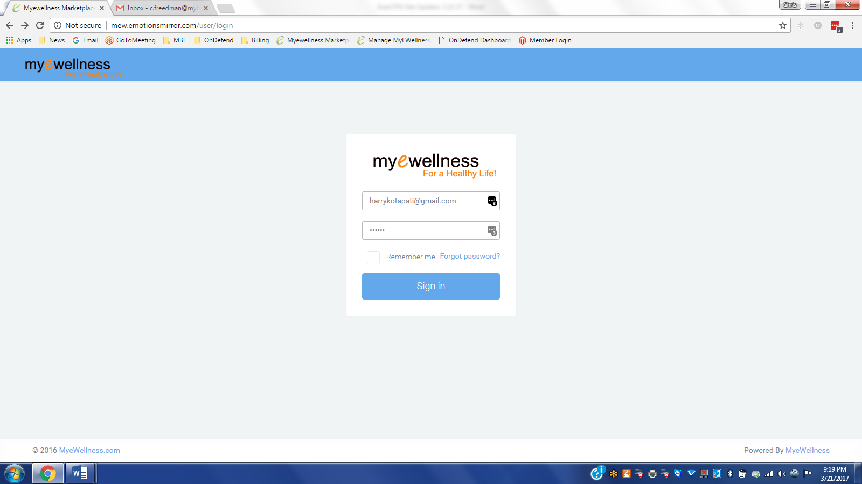

* Need to add option under Forgot Password that says “Can’t login? Click Here”. **(20 min)**
  + This directs to email to Customer Support.
    - This is for new admin login issues.
* Note: I think I deactivated Harry, then reactivated him and it “Deactivated his login”.

**Company &Current Employee Enrollment**

**Pre Enrollment Dashboard View**

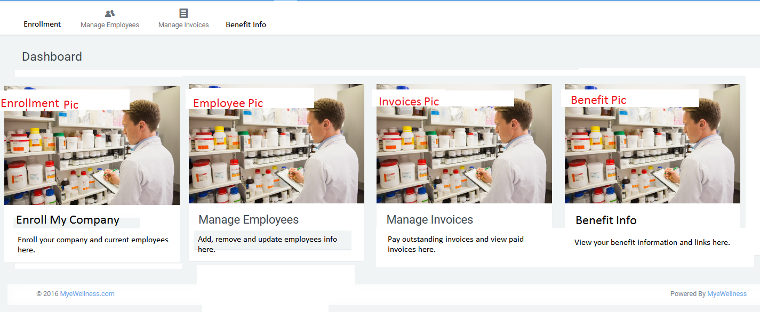

* Above is the dashboard view before the they complete “Enroll My Company”. Options are: **5 hours**
  + For “Manage Employees” and “Manage Invoices”, Maybe:
    - Gray out “Manage Employees” and “Manage Invoices”. If Admin tries to click on them, a pop up says “You must enroll your company and current employees first.”
    - Don’t Gray out “Manage Employees” and “Manage Invoices”.
      * When Admin clicks on “Manage Employees”, a note appears that says “No employees have been enrolled yet. Click Enrollment on dashboard to enroll your company and current employees.”
        + Maybe provide link to “Enrollment” here.
      * When Admin clicks on “Manage Invoices”, a note appears that says “You have not enrolled and activated this benefit yet. Click Enrollment on dashboard to enroll your company and activate this benefit.”
        + Maybe provide link to “Enrollment” here.
  + For “Benefit Info” nothing changes
  + For “Company Profile” (Change “Group” to “Company”), maybe have note that says “You have not enrolled your company yet. Click Enrollment on dashboard to enroll your company.”
* Note if they quite anywhere in the Enroll My Company process, everything above still holds until enrollment is completed.

**(8 hours)**

**Enrollment Pages**

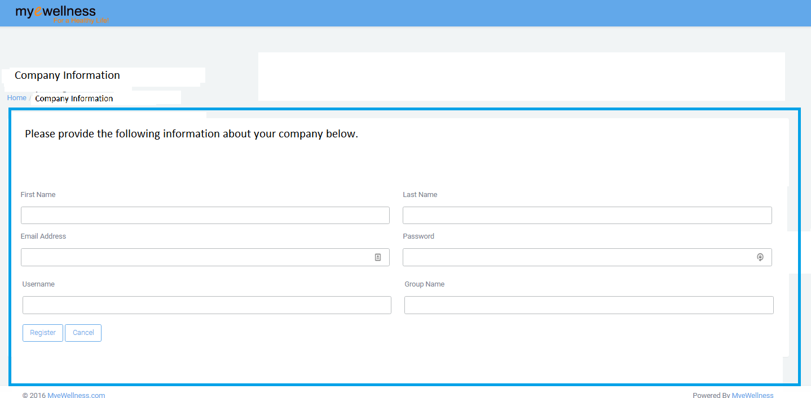

* + They Click on “Enroll My Company” thumbnail.
  + Fill out required information. Needs better outline/border.
    - What is required information?
    - Company name should pull through from earlier Admin Registration.
  + When completed, click “Next”
    - Need better, bolder “Next “ button.

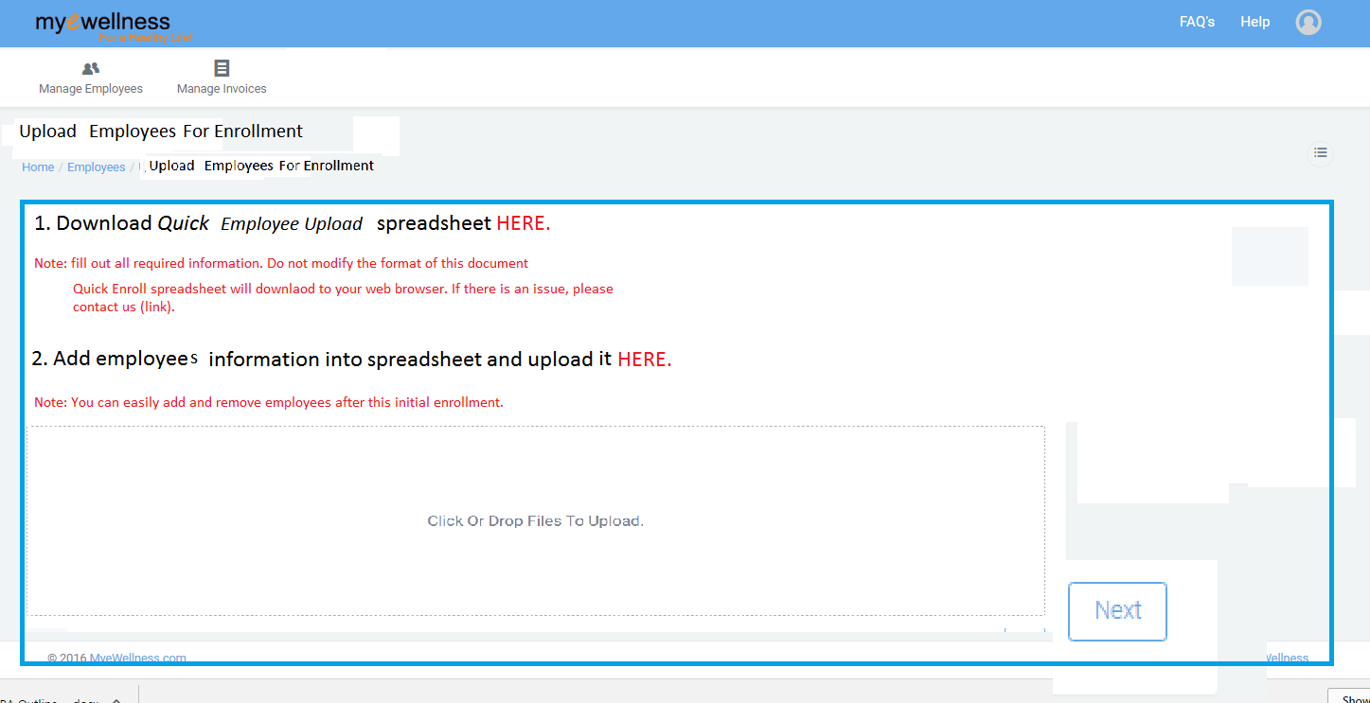

* + Page 2, as shown above, includes (Needs better outline/border):
    - Download spreadsheet
      * 
      * What information above are they required to fill out?
        + We need updated spreadsheet
      * How do we stabilize this form so they don’t mess it up?
      * We need to add a static note to top of spreadsheet with directions.
    - Upload spreadsheet
      * Need Green Checkmark for successful upload.
      * Error message here?
    - When completed, click “Next”
      * **Need better, bolder “Next “ buttons.**

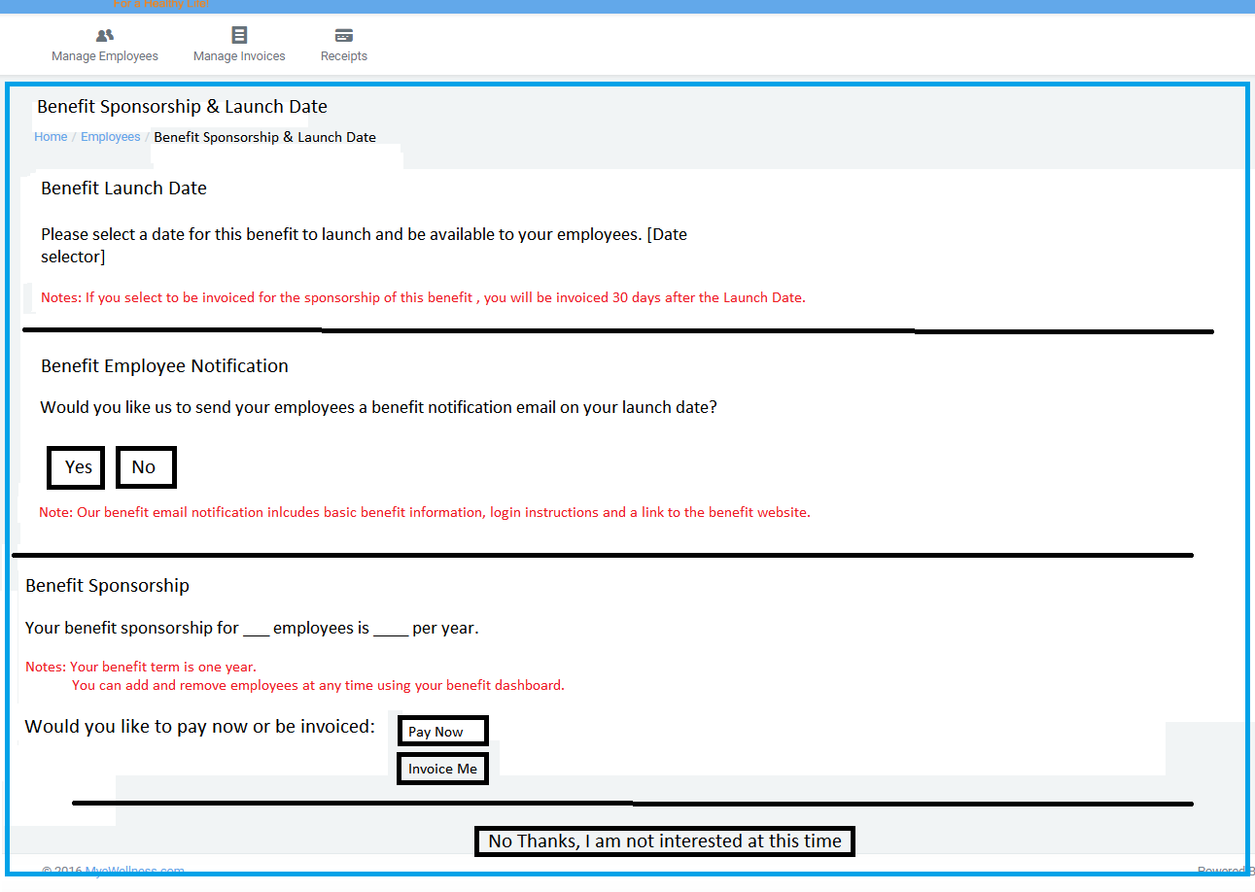

* + Page 2, as shown above, includes (Needs better outline/border.):
    - Benefit Launch Date
      * When section is completed, can we get green check or something to move to next step below?
    - Benefit Notification including following options:
      * Yes
        + If Yes is selected, a pop up says “We will automatically notify your employees of this new benefit upon the launch date that you selected. This notification will include benefit overview information, login instructions and a link to the benefit website.”
      * No
        + If No is selected, we need a popup that says “We will email you a Benefit Launch Date reminder. This email will include directions on how to download your employee’s login instructions for your benefit notification emails.”

Note: We need to add this download option in the Manage Employees page. (see Manage Employees section below)!!!

* + - Benefit Sponsorship Amount
      * When section is completed, can we get green check or something to move to next step below?
    - Payment Options:
      * Pay Now
        + Go to checkout
        + After checkout they have “Thank you for your order and enjoy your new benefit"
      * Invoice
        + If they click Invoice, they are directed to Invoice Page.

Pop up says, “Congratulations, your enrollment was successful! You will receive an invoice email notification when payment is due.”

* + - When complete, click Next.
    - If they click “No Thanks, Not Interested at This Time”, they get an email that says “Thank you for your interest in [MyEWellness}. We will be launching an employee sponsored option for this benefit soon and will reach back out to you when it is available.”

OVERALL NOTE: If admin leaves anywhere in enrollment process, the fields can be auto-filled from past, but any multiple employee download must be automatically deleted and they must do this again. Need popup on Employee Upload page that says “If you uploaded your employees and either left during enrollment process or your account was deactivated, you must upload your current employees again.”

**After Enrollment Dashboard**

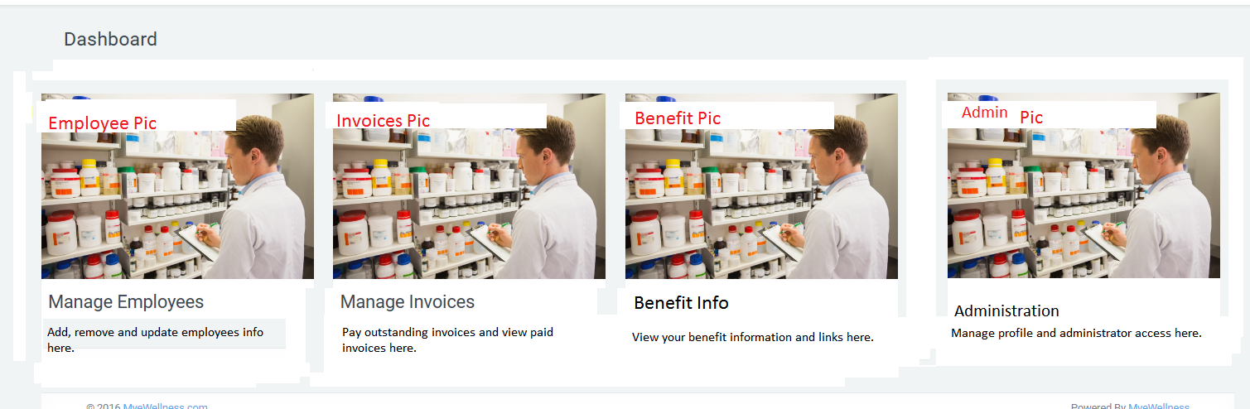

* See updated navigation and tab info above.
* Enrollment thumbnail and navigation disappear.
* Center remaining three tabs.

1. **Manage Employees:**
   1. Email format is colored and weird.
   2. If you edit an employee email or username, will it mess the system up for the employee? **(we should not edit username and email)**
   3. Need cleaner Employee Profile. Use nice grid**. ( design)**
      1. Can we add “Active Products” to this list? **(Need clarification)**
   4. Need “Add Employee” icon to be Green version like OnDefend. When you scroll over it, it needs a popup that says “Add Employee”.
   5. Add Employee tabs:
      1. Add Single Employee
      2. Add Multiple Employees
         1. Use same format for this as Enrollment.
      3. Need to verify fields match up for Single and Multiple Employee Uploads
   6. Need to add “Employee Benefit Login Info”. This takes all of the enrollment employee information as well as login credentials and creates a spreadsheet that the admin can download and use for notifications and other needs.
2. **ManageInvoices**
   1. Unpaid Invoices:
      1. Need “Month” to be “Due Date”.
      2. Status:
         1. Can change to:
            1. Due in ___ days (tied to current date versus launch date?
            2. Payment due
            3. Payment overdue by ____ days
      3. If they do not pay upon our terminated rules/date, when they login they will go to Reactivation Screen which will say “Your benefit has been deactivated due to lack of payment. Do you want to reactivate?”
         1. If they click reactivate button they go through enrollment process again.
      4. Invoice statement needs to be cleaner. See below
         1. Also needs:
            1. Status

due date

date overdue

* + - * 1. Payment term
        2. Employees
        3. Total Cost

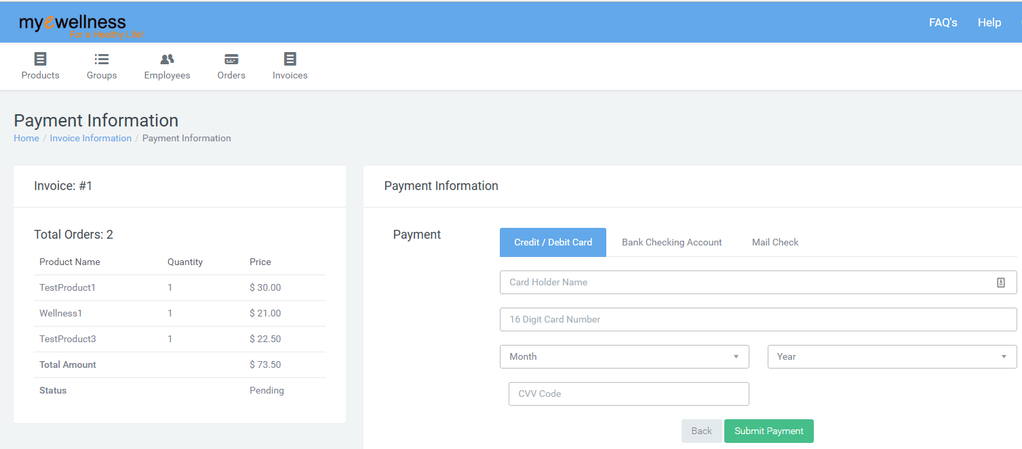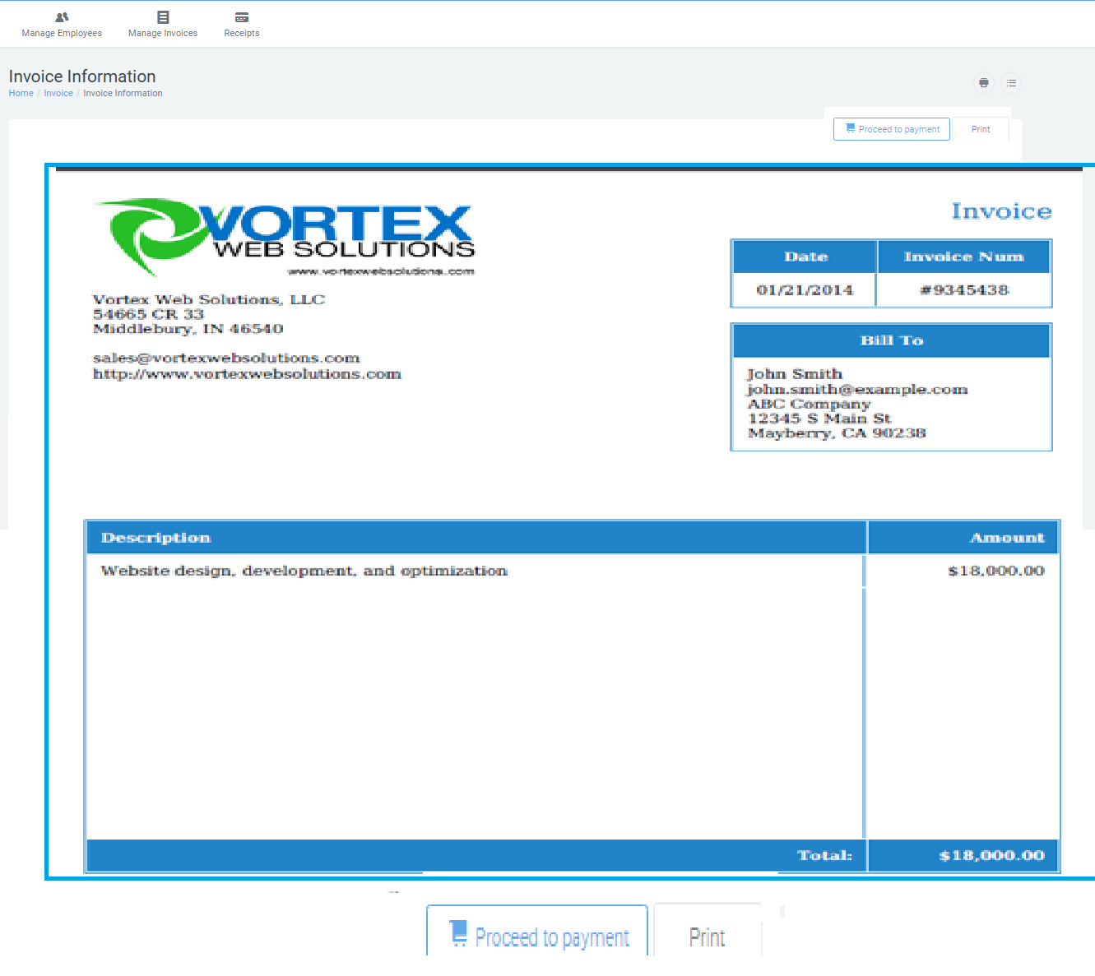

* + 1. Above needs toRemove “Mail Check” Option.
    2. Make Submit Payment bigger and bolder.

1. **Benefits Info**:
   1. Large Tiles for each benefit.
   2. MeW tile only with following info:
      1. Image
      2. Highlights:
         1. Personalized web based workouts with animations
         2. Daily health tips on nutrition, weight-loss, exercise and disease prevention
         3. Over 4,500 current health and wellness related articles with daily feed
         4. Health calculators for easy tracking and self-assessments
         5. Health Risk Assessments
         6. Complete disease and injury library
         7. Health tracking and healthy living points accumulation
         8. Links to hundreds of additional wellness resources
         9. Brand information and additional offers from sponsoring organization
         10. Access to other health and wellness services like lab discounts, telemedicine and advocacy.
      3. Link to MeW
2. **Administration**
   1. Change “Group Profile” to “Company Profile”.
   2. Change “Profile” to “My Profile”
   3. Need cleaner Company and Admin Profiles. Use nice grid.
   4. Move Company Profile and Profile to one page called Administration.
      1. Also add item called “Admin Management” here?
         1. Allows you to:
            1. Add additional administrator
            2. Deactivate administrator

If they try to deactivate last administrator, a pop up says, “There must be one administrator active at all times. If you want to deactivate this administrator, please add another administrator then deactivate this one.”

* + - 1. Lost admins use FAQ/Contact or Account to access us to create new admin.

1. **FAQ’s**
   1. Chris to provide word document.
2. **Help**
   1. Change this to Contact Us form

**(No idea about renewal need clarification )**

1. Renewal:
   1. Account does not renew – All get canceled.
   2. Group does not renew – All employees get canceled.
      1. Group Notice Timing???
2. Product Rates & Terms
   1. Rates set by MeW
   2. Benefit Term – Default 12 months unless MeW sets something different.
3. Delinquent Payments
   1. Termination window set by MeW
   2. Phase 1, we notify them 3 times every 5 days after Launch Date if they have not paid their invoice before we terminate them (terminate at 15 days after launch date without invoice payment).

**Emails 8 hours**

1. Successful Admin Registration
   1. “Congratulations, you have successfully registered as the administrator of this benefit for your company! Now login for your first time and enroll your employees for this benefit.”
      1. Link to login to dashboard
2. Successful Initial Enrollment
3. Invoices(**new**)
   1. 30 days before launch date
   2. 15 days before launch date
   3. 5 days before launch date
   4. Launch date
   5. Delinquent: (**new**)
      1. 5 days after launch date
      2. 10 days after launch date
      3. 15 days after launch date
   6. Successful invoice payment
4. No Thanks, Not Interested at This Time **(new)**
   1. “Thank you for your interest in [MyEWellness}. We will be launching an employee sponsored option for this benefit soon and will reach back out to you when it is available.”
5. Email to employees for benefitnotification **(new)**
6. Benefit Launch Date reminder (if they want to notify) **(new)**
   1. This needs to direct them to Manage Employees “Employee Benefit Login Info”.
7. Upcoming Renewal**(new)**
   1. 60 days from renewal
   2. 30 days from renewal
   3. 5 days from renewal
   4. Renewal day
      1. Delinquent:
         1. 5 days after launch date
         2. 10 days after launch date
         3. 15 days after launch date
8. Successful Renewal**(new)**
9. Declined Renewal**(new)**
10. Add Employee
11. Deactivate Employee
12. Password Change